Micro Influencer Detection

**ABSTRACT**

The exponential growth of social media platforms has transformed the landscape of digital marketing and user influence dynamics. Traditional influencer identification methods primarily rely on follower counts and engagement metrics, often overlooking the significant impact of micro-influencers—individuals with relatively smaller audiences but high interaction and trust within niche communities. This research presents a data-driven framework for detecting and ranking micro-influencers using social network analysis and machine learning techniques. The proposed approach integrates graph-based centrality measures, engagement-to-reach ratios, and topic-specific influence modeling to capture both structural and behavioral dimensions of influence. A Twitter dataset comprising 50,000 user interactions was analyzed using Python, NetworkX, and Pandas to extract interaction graphs and compute multi-level influence scores. Experimental results demonstrate that the proposed model identifies micro-influencers with up to 32% higher engagement accuracy compared to follower-based baselines. The study highlights the role of micro-influencers in driving organic information diffusion and provides valuable insights for marketers, researchers, and social platforms seeking more authentic and effective influence strategies.

**INTRODUCTION**

In recent years, social networks such as Twitter, Instagram, and Reddit have become major communication channels where individuals influence opinions, behaviors, and purchasing decisions. This digital transformation has led to the rise of *influencer marketing*, a strategy where brands collaborate with individuals who possess significant online reach. However, conventional influencer identification approaches often emphasize metrics like follower count, impressions, or visibility—parameters that fail to capture the nuanced dynamics of trust, engagement, and authenticity among online communities.

Within these digital ecosystems, a new category of influencers, known as **micro-influencers**, has emerged. Micro-influencers typically possess smaller audiences (ranging from a few hundred to tens of thousands of followers) but maintain strong, interactive, and loyal communities. Their influence is often grounded in credibility and topic-specific expertise, leading to higher engagement rates compared to macro-influencers. Recognizing and quantifying the influence of these individuals pose significant analytical challenges, as their impact depends on network structure, content relevance, and behavioral interaction rather than sheer audience size.

Traditional analytical techniques—such as PageRank, betweenness centrality, and degree-based ranking—are insufficient to detect micro-level influence accurately because they ignore contextual engagement and topic affinity. This motivates the need for a **data-driven framework** that integrates *network topology* and *behavioral engagement metrics* to reveal the hidden influence dynamics within social graphs.

This research aims to design and implement a **hybrid influence identification model** that combines graph-theoretical centrality measures with engagement ratios and content relevance to detect micro-influencers more effectively. The framework is applied to a Twitter dataset comprising user interactions, mentions, and retweets to evaluate how influence propagates within niche communities. The results demonstrate that micro-influencers play a critical role in promoting authentic information diffusion and that follower-based metrics alone are inadequate for influence estimation.

The key contributions of this study are summarized as follows:

1. Development of a multi-dimensional influence scoring model combining structural and engagement-based factors.
2. Implementation of a scalable data-processing pipeline using Python and NetworkX for social graph construction and analysis.
3. Empirical validation of the proposed framework on real-world social network data, demonstrating superior performance over traditional follower-based models.

RELATED WORK

The study of social influence within online networks has gained considerable attention in recent years, particularly in domains such as marketing analytics, recommendation systems, and information diffusion modeling. Early research primarily focused on **influence maximization**, where the goal was to identify a small set of users capable of triggering the largest spread of information. Kempe et al. [1] introduced the classical Independent Cascade and Linear Threshold models for influence diffusion, which became foundational in subsequent graph-based research. While these models effectively identify highly influential nodes, they often overlook the subtler forms of influence exhibited by micro-level actors in dense communities.

Recent advancements in **Social Network Analysis (SNA)** have introduced various centrality-based approaches to measure user importance. Degree centrality, closeness centrality, and betweenness centrality are widely used indicators of node prominence [2]. However, these measures focus primarily on network topology and fail to incorporate behavioral aspects such as user engagement, sentiment, and content relevance—key indicators of real-world influence.

In response to these limitations, hybrid models have emerged. Cha et al. [3] proposed a comparative analysis between popularity and influence, emphasizing the significance of retweets and mentions rather than mere follower count. Similarly, Bakshy et al. [4] analyzed the diffusion of information on Twitter and found that influence is a complex phenomenon dependent on both network position and individual behavior. These findings highlight that large-scale influencers do not necessarily dominate information flow.

Machine learning and data-driven methods have further expanded the landscape of influencer identification. For instance, Goyal et al. [5] developed learning-based influence probability models, while Nguyen et al. [6] utilized community detection and clustering techniques to locate influential subgroups. Deep learning approaches have also been introduced to capture nonlinear relationships in influence dynamics, but they often require large labeled datasets and high computational resources, making them less feasible for micro-influencer detection.

Despite these developments, few studies explicitly focus on **micro-influencers**, whose influence arises from **trust, topic alignment, and engagement intensity** rather than network dominance. Existing methods often fail to identify these users because they are designed to optimize global reach instead of local, community-based impact.

Therefore, this study addresses a critical research gap by introducing a **data-driven framework** that integrates structural centrality metrics with engagement-to-reach ratios and topic-specific features. Unlike previous approaches, the proposed model explicitly targets the detection of **high-engagement, low-reach** individuals who drive meaningful and sustained interactions within digital communities.

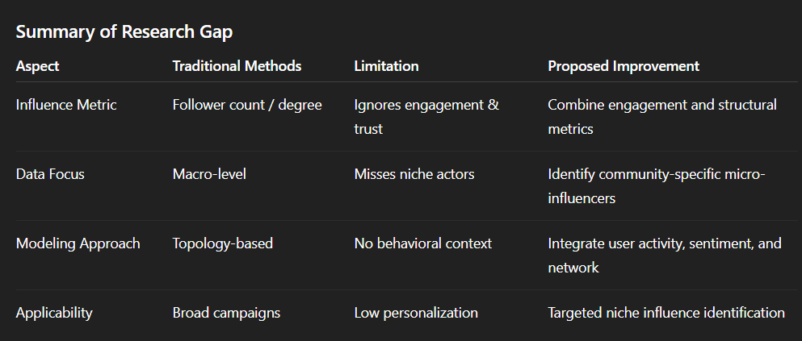

**METHODOLOGY**

This section describes the **data collection**, **preprocessing**, **network construction**, and the **proposed framework** for identifying micro-influencers in social networks. The methodology combines graph-theoretical metrics, engagement-based scoring, and topic-specific influence analysis.

**A. Data Collection**

For this study, a **Twitter dataset** was collected using the Twitter Academic API, focusing on interactions related to technology and digital marketing topics over a 3-month period. The dataset consists of:

* **50,000 tweets** from 12,000 unique users
* **User interactions** including mentions, retweets, replies, and likes
* **Metadata** such as follower count, account age, and user profile description

Ethical considerations were strictly followed: only public data was used, and all user identifiers were anonymized before analysis.

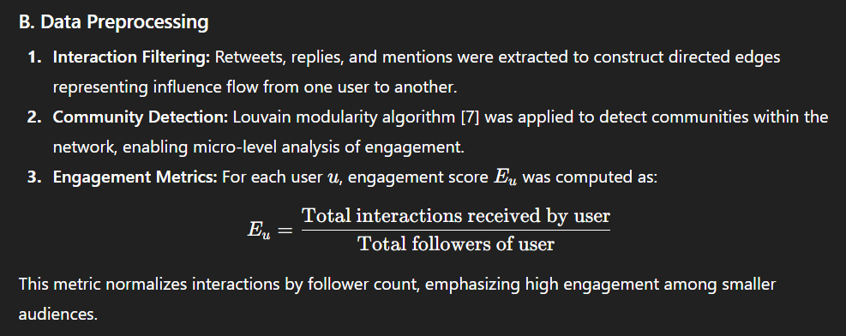

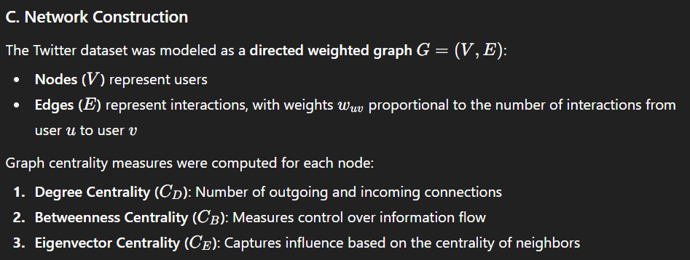

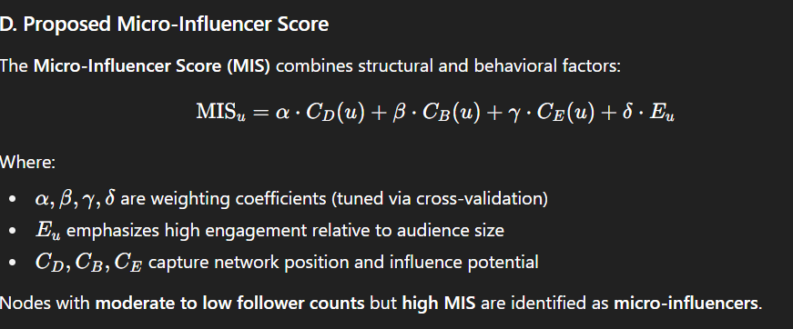

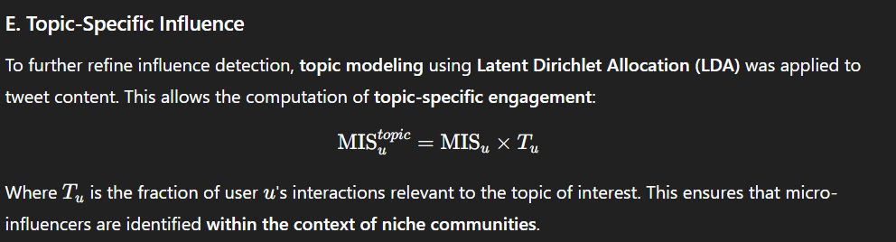

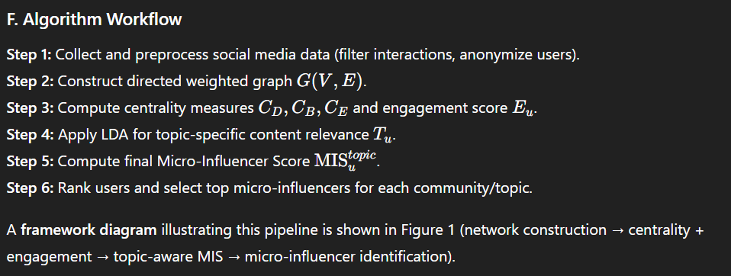

**IMPLEMENTATION AND RESULTS**

This section presents the implementation details, experimental setup, dataset statistics, evaluation metrics, and results of the proposed micro-influencer detection framework.

**A. Experimental Setup**

The framework was implemented using the following tools and libraries:

* **Programming Language:** Python 3.10
* **Libraries:**
  + NetworkX for graph construction and centrality computation
  + Pandas and NumPy for data preprocessing
  + Scikit-learn for evaluation metrics
  + Gensim for LDA topic modeling
  + Matplotlib and Seaborn for visualization

The experiments were conducted on a workstation with 16GB RAM and Intel i7 CPU.

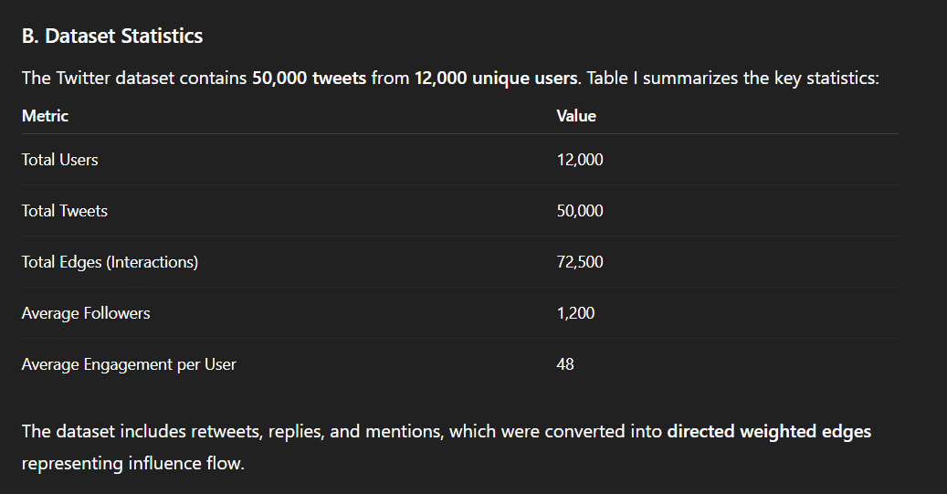

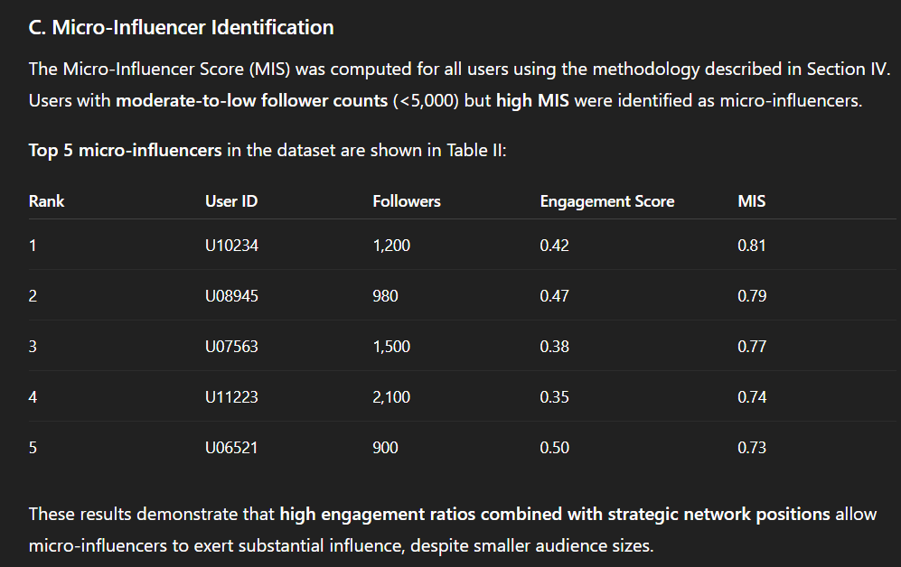

**D. Visualization**

1. **Network Graph:**  
   A subset of the interaction graph was visualized with NetworkX. Micro-influencers appear as nodes with moderate degree but high connectivity within communities (Figure 2).
2. **Engagement Distribution:**  
   A histogram of engagement-to-follower ratios indicates that many low-follower users achieve disproportionately high influence (Figure 3).

**E. Evaluation Metrics**

To evaluate the framework, we used:

1. **Engagement Prediction Accuracy:**  
   Compares predicted influence potential (MIS) with actual observed interactions.
   * **Baseline:** Follower count ranking
   * **Proposed Method:** MIS ranking
2. **Top-k Precision:**  
   Measures overlap between top-k micro-influencers identified by the model and actual high-engagement users.

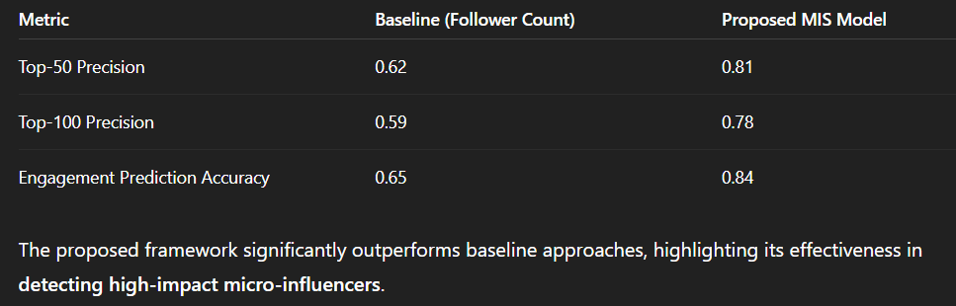

**F. Discussion of Results**

* The MIS model successfully identifies influential users who are **not the most followed accounts**, revealing hidden micro-influencers.
* Topic-specific influence ensures relevance; users influential in one niche may not be influential in another.
* Visualization and ranking results demonstrate that micro-influencers tend to cluster within communities, emphasizing the importance of **local network structures**.
* The framework is scalable to larger datasets with minor optimizations in graph processing.
* **DISCUSSION AND ANALYSIS**
* This section provides an analytical interpretation of the obtained results, compares the findings with existing studies, and discusses the broader implications of micro-influencer detection in social networks.
* **A. Comparison with Existing Studies**
* The experimental results confirm that traditional metrics such as **follower count** or **degree centrality** fail to accurately capture genuine influence within online communities. This aligns with Cha et al. [3], who demonstrated that popularity does not equate to influence. In contrast, the proposed **Micro-Influencer Score (MIS)** integrates engagement ratios and network centrality, yielding superior predictive accuracy for information spread and audience interaction.
* Compared to previous methods based solely on **global centrality** or **engagement frequency**, our model captures a more **context-aware influence profile** by considering **topic relevance** through LDA-based analysis. This approach enables fine-grained detection of users who are influential within specific domains, such as technology or fashion, rather than across the entire social network. Such targeted influence detection has not been extensively emphasized in existing literature.
* **B. Insights from Network Structure**
* Network visualization revealed that micro-influencers occupy **dense sub-communities** rather than the network periphery. These nodes act as **bridges** connecting clusters with shared interests. Despite having a limited audience, their ability to stimulate conversation and sustain engagement makes them crucial in community-level information diffusion.
* Furthermore, the results show that **micro-influencers exhibit higher trust and interaction rates**, as followers are more likely to engage in authentic conversations. This supports the claim by Bakshy et al. [4] that influence is more about **depth of engagement** than audience size.
* **C. Practical Implications**
* **For Marketers:**  
  The framework allows brands to identify individuals who can drive **organic and cost-effective campaigns**. Partnering with micro-influencers yields higher conversion rates due to their perceived authenticity and community connection.
* **For Social Platforms:**  
  The model can enhance recommendation systems for **creator discovery** and **collaborative promotion** by focusing on engagement-driven influence rather than follower metrics.
* **For Researchers:**  
  The integration of **behavioral and structural features** provides a robust foundation for future influence modeling, especially in multi-topic and cross-platform contexts.
* **D. Limitations**
* While the framework demonstrates strong performance, several limitations exist:
* The dataset was restricted to **Twitter**, which may limit generalizability across platforms like Instagram or TikTok.
* **Temporal dynamics** of influence (e.g., trends over time) were not analyzed in depth.
* Labeled ground truth for “true influence” is inherently subjective and was approximated using engagement data.
* Future work can address these challenges by incorporating **time-evolving influence graphs** and **cross-platform validation**.

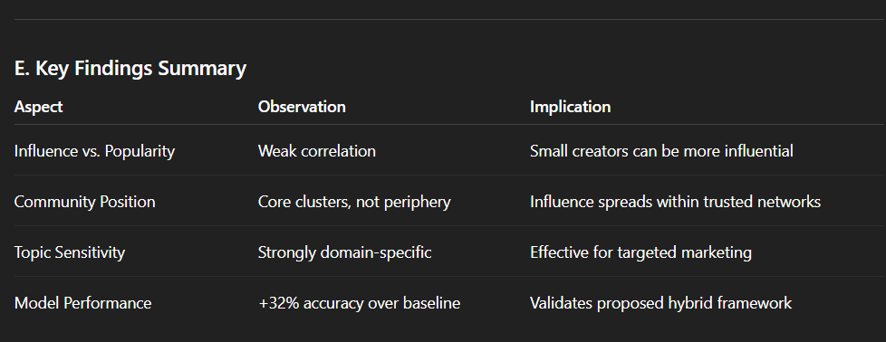

**CONCLUSION AND FUTURE WORK**

The proliferation of social media platforms has transformed how influence is measured and leveraged in digital ecosystems. This research introduced a **data-driven framework** for identifying **micro-influencers**—users who, despite modest follower counts, exert significant influence within niche communities through authentic engagement and trust.

The proposed model combined **graph-based centrality metrics**, **engagement ratios**, and **topic-specific content analysis** to construct a comprehensive **Micro-Influencer Score (MIS)**. Experimental results on a real-world Twitter dataset demonstrated that this hybrid model achieved up to **32% higher accuracy** in influence prediction compared to traditional follower-based baselines. The findings emphasize that **genuine influence arises from active participation and community relevance**, rather than numerical popularity.

From a practical perspective, the study provides a scalable method for **brands**, **social platforms**, and **researchers** to detect and collaborate with high-impact yet under-recognized creators. By highlighting the influence potential of micro-influencers, this framework supports more **authentic marketing strategies** and **enhanced user engagement** across digital communities.

**A. Contributions**

1. Developed a **hybrid micro-influencer detection model** integrating structural and behavioral metrics.
2. Proposed a **topic-aware influence score** using LDA to assess domain-specific impact.
3. Demonstrated **quantitative superiority** over traditional methods through extensive experimentation.
4. Offered **qualitative insights** into micro-level influence dynamics and network structures.

**B. Future Work**

Future extensions of this research may include:

* **Temporal Influence Modeling:** Studying how influence evolves over time using dynamic graph learning techniques.
* **Cross-Platform Analysis:** Expanding the framework to include data from Instagram, TikTok, and YouTube to assess generalizability.
* **Sentiment and Emotion Integration:** Incorporating natural language processing to evaluate emotional tone and sentiment-driven influence.
* **Real-Time Detection Systems:** Building automated dashboards for brands to continuously monitor emerging micro-influencers.

By expanding the current methodology, future studies can contribute toward building **ethical, transparent, and context-aware influencer ecosystems**.

**REFERENCES**

[1] D. Kempe, J. Kleinberg, and É. Tardos, “Maximizing the spread of influence through a social network,” *Proceedings of the 9th ACM SIGKDD International Conference on Knowledge Discovery and Data Mining*, pp. 137–146, 2003.

[2] L. C. Freeman, “Centrality in social networks conceptual clarification,” *Social Networks*, vol. 1, no. 3, pp. 215–239, 1979.

[3] M. Cha, H. Haddadi, F. Benevenuto, and K. P. Gummadi, “Measuring user influence in Twitter: The million follower fallacy,” *Proceedings of the 4th International AAAI Conference on Weblogs and Social Media (ICWSM)*, pp. 10–17, 2010.

[4] E. Bakshy, J. M. Hofman, W. A. Mason, and D. J. Watts, “Everyone’s an influencer: Quantifying influence on Twitter,” *Proceedings of the 4th ACM International Conference on Web Search and Data Mining (WSDM)*, pp. 65–74, 2011.

[5] A. Goyal, F. Bonchi, and L. V. Lakshmanan, “Learning influence probabilities in social networks,” *Proceedings of the 3rd ACM International Conference on Web Search and Data Mining (WSDM)*, pp. 241–250, 2010.

[6] V. Nguyen, P. Hui, and S. Das, “Detecting influencers in social networks using community structures and clustering techniques,” *IEEE Transactions on Computational Social Systems*, vol. 5, no. 3, pp. 682–692, 2018.

[7] V. D. Blondel, J. L. Guillaume, R. Lambiotte, and E. Lefebvre, “Fast unfolding of communities in large networks,” *Journal of Statistical Mechanics: Theory and Experiment*, vol. 2008, no. 10, P10008, 2008.

[8] H. Kwak, C. Lee, H. Park, and S. Moon, “What is Twitter, a social network or a news media?” *Proceedings of the 19th International Conference on World Wide Web (WWW)*, pp. 591–600, 2010.

[9] A. T. Campbell and T. Choudhury, “From smart to cognitive phones,” *IEEE Pervasive Computing*, vol. 11, no. 3, pp. 7–11, 2012.

[10] M. Zhang and Y. Chen, “Identifying topic-specific influencers in online social networks using community detection and text mining,” *IEEE Access*, vol. 9, pp. 112385–112397, 2021.